Practical 4
Aim
To configure virtual machine resources such as CPU, RAM, and storage, manage the virtual hard disk, and configure a shared folder between the host operating system and the virtual machine using VMware Workstation.
Requirements
- VMware Workstation
- A previously created virtual machine: POV-Lab (Practical-3)
- Ubuntu 20.04.6 Desktop installed in the virtual machine
- Sufficient CPU, RAM, and storage resources on the host computer
Objectives
After completing this practical, the following tasks will be performed:
- Configure the CPU resources of the virtual machine.
- Configure the RAM allocated to the virtual machine.
- Configure the virtual hard disk and storage.
- Configure a shared folder between the host and guest operating systems.
- Verify the configured resources and shared-folder access.
Procedure
1. Open VMware Workstation
- Launch VMware Workstation.

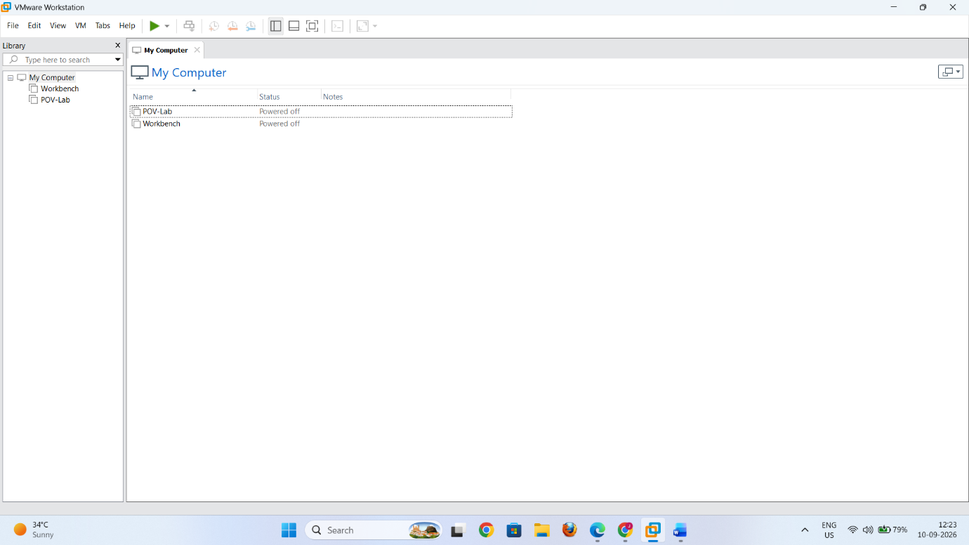
- Select the virtual machine POV-Lab from the virtual machine list.
- Make sure the virtual machine is powered off before changing its hardware configuration.

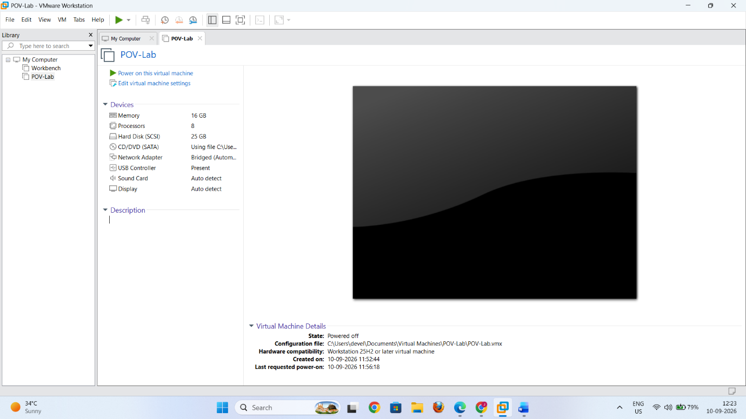
2. Configure CPU Resources
- Select POV-Lab.
- Click Edit virtual machine settings.
- Select Processors.
- Configure the processor settings according to the available hardware.

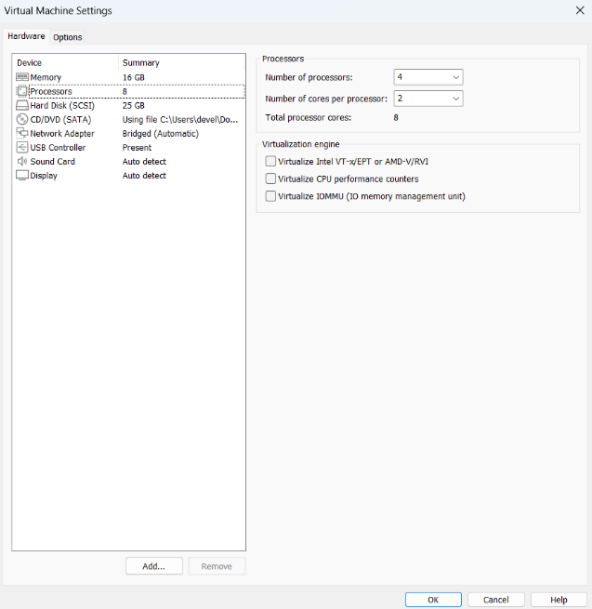
For this practical, configure:
- Number of processor cores: 2 or 4 (and select 2 cores per processor)
- Click OK or proceed to configure the remaining hardware settings.
The virtual machine will now have two virtual CPU cores available to the guest operating system.
3. Configure RAM
- Open Edit virtual machine settings again.
- Select Memory.
- Set the memory allocated to the virtual machine.

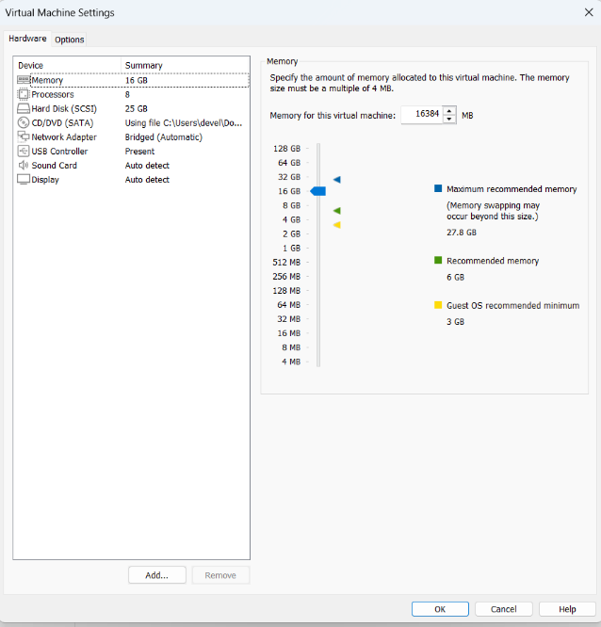
For this practical:
- Memory: 4/8/16 GB (4096 MB/ 8192 MB/16384 MB)
- Make sure the allocated memory is within the recommended range shown by VMware Workstation.
- Click OK to save the setting.
The Ubuntu virtual machine will now have 4/8/16 GB of virtual RAM.
4. Configure Virtual Hard Disk
- Open Edit virtual machine settings.
- Select the existing Hard Disk.
- Check the current virtual disk capacity.

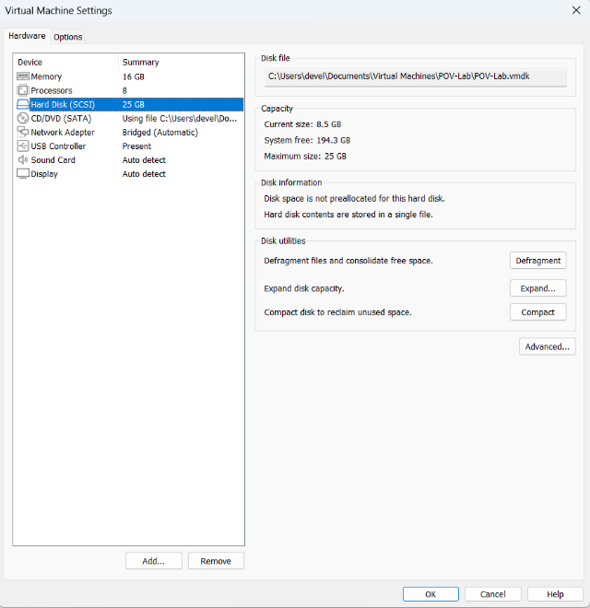
For this practical, use a virtual disk of approximately:
- Storage capacity: 25–30 GB
- If additional storage is required, VMware Workstation can be used to expand the virtual disk.
- Click Expand if the virtual disk needs to be increased.
- Enter the required new maximum disk size.
- Confirm the operation.

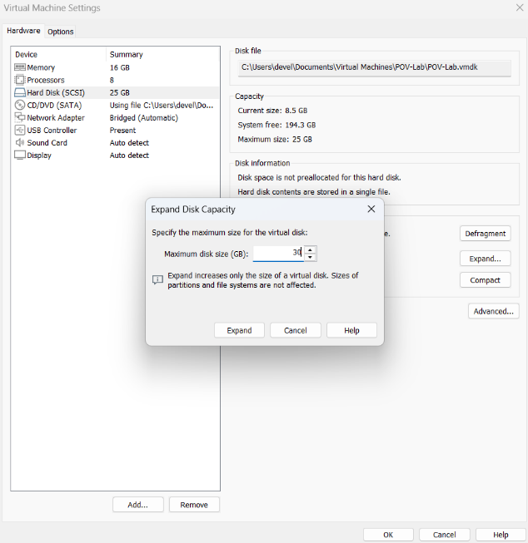
The virtual hard disk is stored as a file or group of files on the host computer. Changes to the virtual disk should be made carefully because they affect the storage available to the guest operating system.
5. Configure a Shared Folder
A shared folder allows files to be exchanged between the host operating system and the Ubuntu guest operating system.
First, create a folder on the host computer, for example:
VM-Shared
Then:
- In VMware Workstation, select POV-Lab.
- Open Edit virtual machine settings.
- Select the Options tab.
- Select Shared Folders.
- Select Always enabled.
- Click Add.
- The Shared Folder Wizard will open.
- Click Next.
- Browse to the folder created on the host computer.
- Enter a name for the shared folder, such as:
VM-Shared
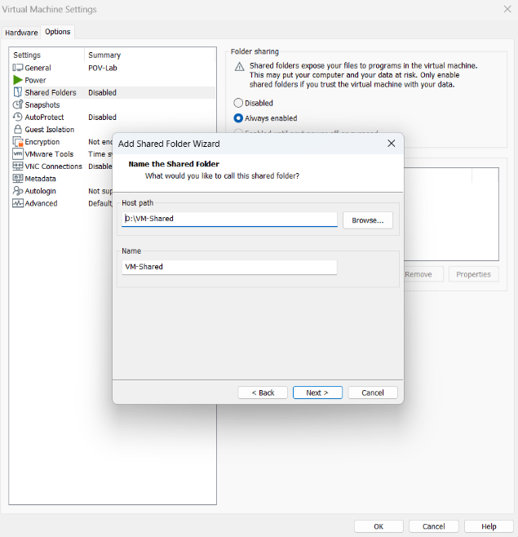
- Enable the option to make the folder available to the virtual machine.
- Click Finish.

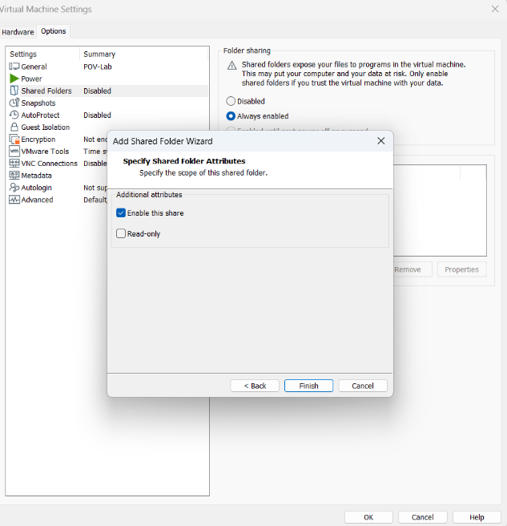
- Click OK to save the configuration.

6. Start the Virtual Machine
- Power on POV-Lab.
- Log in to Ubuntu.
- Wait for the Ubuntu desktop to load.
7. Verify CPU and RAM
Open Terminal in Ubuntu and use the following commands.
To check the number of available CPU cores:
nproc
The output should correspond to the CPU resources allocated to the VM.

To check the available memory:
free -h
The output will display the RAM available to Ubuntu.
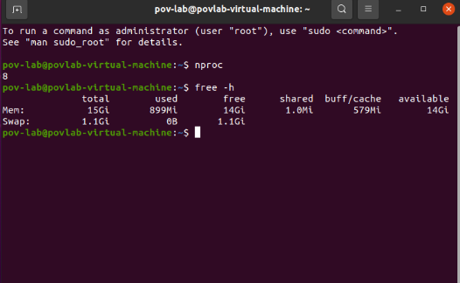

8. Verify Storage
To view the virtual disk and its partitions, open Terminal and execute:
Lsblk
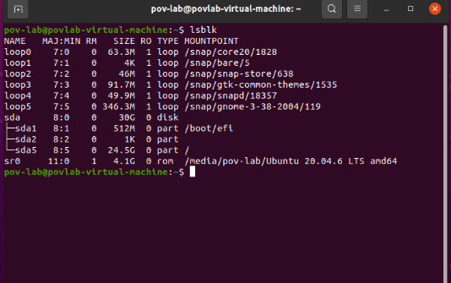
To check available disk space:
df -h
These commands display the storage devices, partitions, and available space inside the Ubuntu virtual machine.

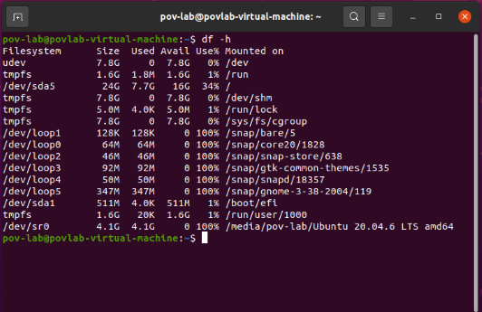
9. Setup and Verify the Shared Folder in VM
9.1 Start the Virtual Machine and Check VMware Tools
- Power on POV-Lab.
- Log in to Ubuntu.
- Open Terminal.
- Check whether VMware Tools is installed by running:
vmware-toolbox-cmd -v

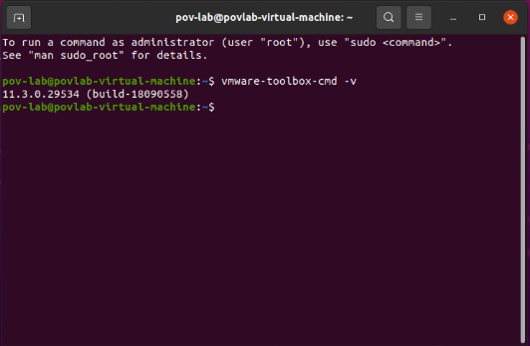
- A VMware Tools version number should be displayed.
9.2 Check the Configured Shared Folder
Run the following command:
vmware-hgfsclient

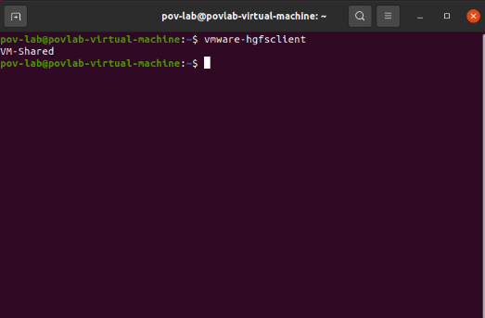
The configured shared folder should be displayed:
VM-Shared
This confirms that VMware Workstation can detect the shared folder.
9.3 Create the Shared-Folder Mount Point
Create the standard VMware shared-folder mount directory using:
sudo mkdir -p /mnt/hgfs
Enter the Ubuntu user password when prompted.

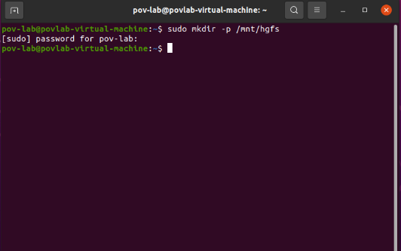
9.4 Mount the VMware Shared Folder
Mount the shared folders using the following command:
sudo vmhgfs-fuse .host:/ /mnt/hgfs -o allow_other

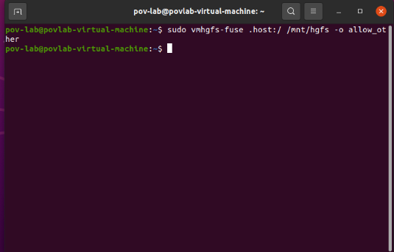
After mounting, display the available shared folders using:
ls /mnt/hgfs
The following folder should be displayed:
VM-Shared

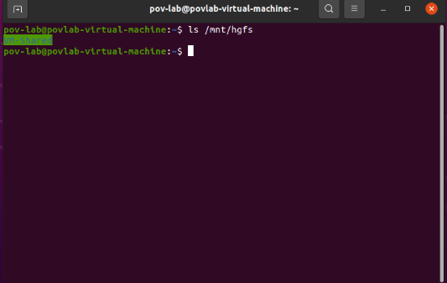
9.5 Access the Shared Folder
Navigate to the shared folder using:
cd /mnt/hgfs/VM-Shared
Display its contents using:
ls

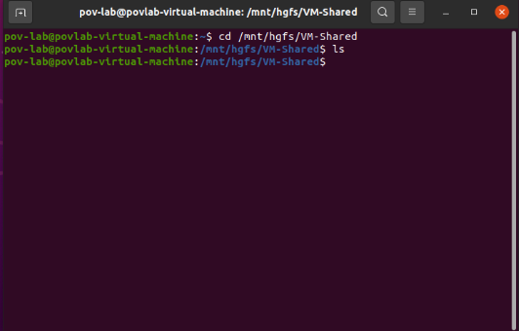
9.6 Test File Sharing
Create a test file inside the shared folder:
touch test.txt
Verify that the file has been created:
ls
The output should contain:
test.txt

Now open the VM-Shared folder on the host computer and verify that test.txt is visible there.
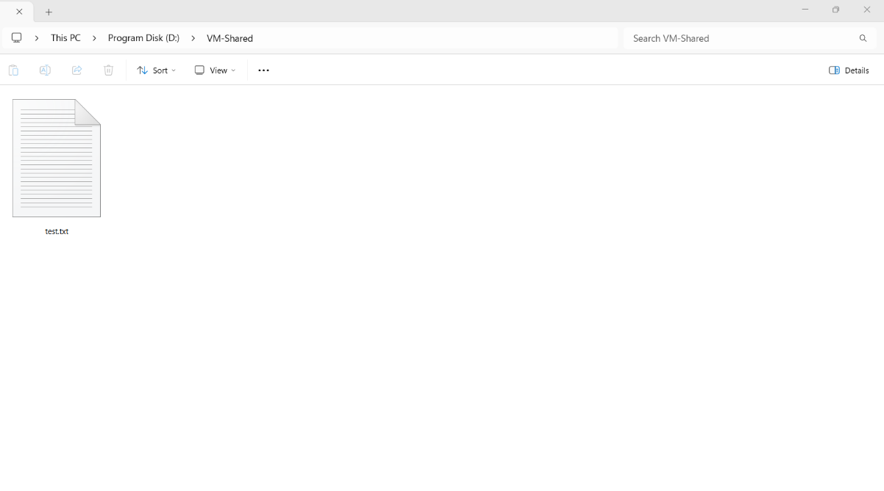
Similarly, create a file in the VM-Shared folder on the host computer.

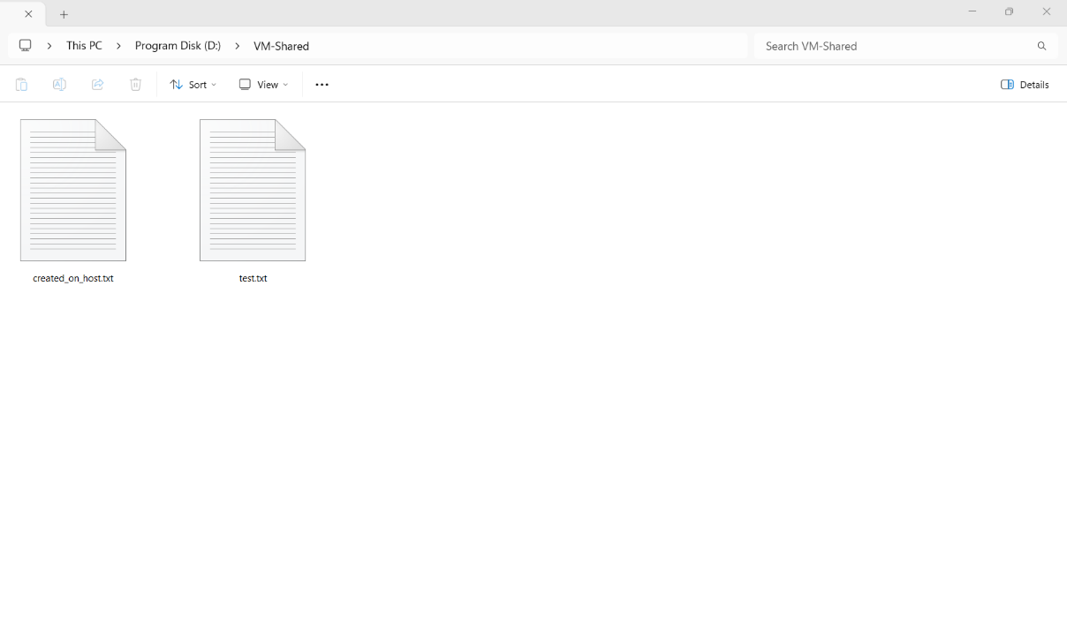
Then run:
ls
inside Ubuntu to verify that the file is accessible from the guest operating system.
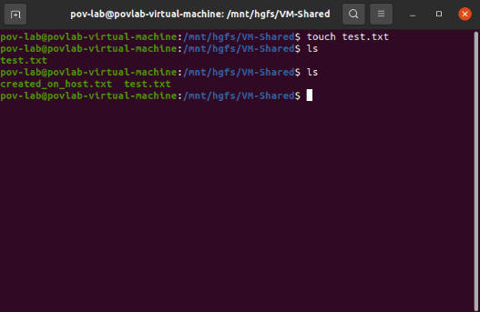
Configured Resources
Resource | Configuration
Virtual Machine | POV-Lab
CPU | 4 cores * 2
RAM | 16 GB
Virtual Hard Disk | 30 GB
Network | Bridged
Shared Folder | VM-Shared
Guest OS | Ubuntu 20.04.6 Desktop
Result
The virtual machine POV-Lab was successfully configured with the required CPU, RAM, and storage resources. The virtual hard disk was configured and verified, and a shared folder named VM-Shared was successfully configured for file exchange between the host operating system and the Ubuntu guest operating system.

